Chapter 10, Solution 54.

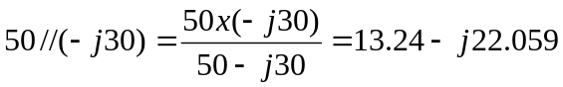
We convert the current source to voltage source and obtain the circuit below.

13.24 – j22.059
40 j20

+ + -
V_{s} =115.91 –j31.06V I
134.95-j74.912 V
V
- +

-

Applying KVL gives

-115.91 + j31.058 + (53.24-j2.059)I -134.95 + j74.912 = 0

or 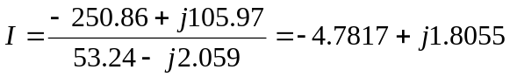

But

which agrees with the result in Prob. 10.7.

